Read chapter 4 in your textbook. The following review questions should help guide your reading. **Points possible 32**

For each question, you should give a correct answer (as best you know it) or provide an intelligent question regarding the reading that applies to this question and explains why you could not answer the question. (Please note that "I didn't understand any of this" isn't a question, isn't intelligent, and has spelling and grammar errors. It will receive 0 points.)

**Make sure to show your work. Answer the questions using your own words and understandings on the chapter materials.**

1. R2. **(1 Points)** We noted that network layer functionality can be broadly divided into data plane functionality and control plane functionality. What are the main functions of the data plane? Of the control plane?
   1. Data Plane:
      1. Local, per-router functionality.
      2. Determines how datagram arriving on router input port is forwarded to router output port
      3. Forwarding Function
   2. Control Plane
      1. Network-wide logic
      2. Determines how datagram is routed amoung routers along end-end path from src to hst
      3. Traditional routing algos vs SDN

1. R8. **(1 Points)** What is meant by destination-based forwarding? How does this differ from generalized forwarding (assuming you’ve read Section 4.4, which of the two approaches are adopted by Software-Defined Networking)?
   1. Generalized forwarding: Each packet switch contains a match-plus-action table that is computed and distributed by a remote controller
   2. Destination-based forwarding: An arriving packet comes with the destination address of where the packet has to reach. This is adopted by SDN
2. R14. **(1 Points)** In Section 4.2 , we studied FIFO, Priority, Round Robin (RR), and Weighted Fair Queueing (WFQ) packet scheduling disciplines? Which of these queueing disciplines ensure that all packets depart in the order in which they arrived?
   1. FIFO (First In First Out)
3. R17. **(1 Points)** Suppose Host A sends Host B a TCP segment encapsulated in an IP datagram. When Host B receives the datagram, how does the network layer in Host B know it should pass the segment (that is, the payload of the datagram) to TCP rather than to UDP or to some other upper-layer protocol?
   1. In IPv6 and IPv4 we would just need to check the “Next header” field which is used to identify the protocol.
4. R20. **(2 Points)** When a large datagram is fragmented into multiple smaller datagrams, where are these smaller datagrams reassembled into a single larger datagram?
   1. They are reassembled at the destination according to protocols that are defined before
5. R22. **(2 Points)** What is the 32-bit binary equivalent of the IP address 221.31.16.21?
   1. 11011101.00011111.00010000.00010101
6. R23. **(2 Points)** Visit a host (this can be your personal computer) that uses DHCP to obtain its IP address, network mask, default router, and IP address of its local DNS server. List these values. Explains the functions of each of these sections (IP address, network mask, default Gateway, and DNS server). What services they provide to your computer.
   1. Host IP address: 10.250.13.163 – The IP address assigned to my machine by DHCP
   2. Network Mask: 225.225.192.0 – The range of IP addresses available
   3. DNS server IP: 127.0.0.53 – Where all traffic runs through
7. R26. **(5 Points)** Suppose you purchase a wireless router and connect it to your cable modem. Also suppose that your ISP dynamically assigns your connected device (that is, your wireless router) **one IP** address. What type of address is this (private or public, explain)? Also suppose that you have five PCs at home that use 802.11 to wirelessly connect to your wireless router. How are IP addresses assigned to the five PCs? Does the wireless router use NAT? Why or why not, explain? Draw a diagram of NAT process including information of the NAT table, that one of your clients (192.168.1.2:55535) accessing an internet weber server xaver.edu (209.87.150.139:80) through your router. Pick a random port for the NAT translation.
   1. It is a public IP address as it directly interacts to the internet. IP addresses on your 5 at home PCs are assigned under the one IP address and your router uses NAT to remap where the packets are supposed to go.
8. **(5 Points)** Remember that routing table tells what interface is connected to what network address. Example 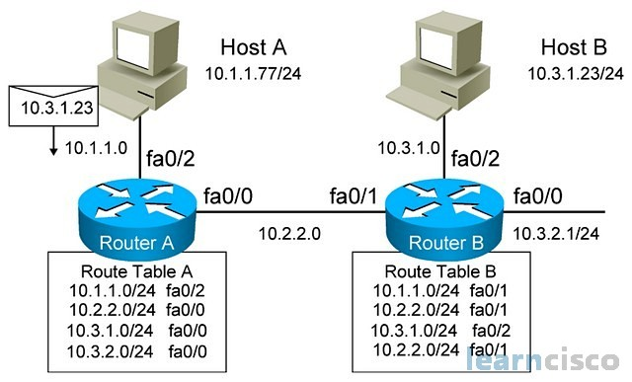

Consider the network below

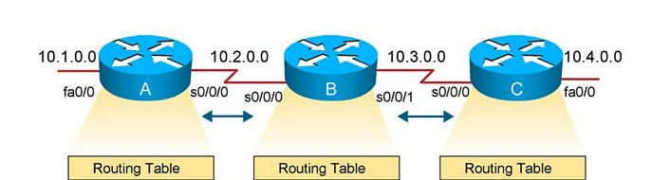

* 1. Show the forwarding table in router A, B and C such that all traffic destined to network 10.4.0.0 is forwarded through interface Fa0/0.
     1. Very lost on this one. Not sure where to begin constructing a forwarding table

1. **(5 Points)** Consider a datagram network using 8-bit host addresses. Suppose a router uses longest prefix matching and has the following forwarding table:

|  |  |
| --- | --- |
| Prefix Match | Interface |
| 00000000 | 0 |
| 01000000 | 1 |
| 01100000 | 2 |
| 10000000 | 2 |
| 11000000 | 3 |

For each of the four interfaces, give the associated range of destination host addresses and the number of addresses in the range. First one is completed for you!

|  |  |
| --- | --- |
| Destination Address Range | Link Interface |
| 00000000 through 00111111 | 0 |
| 01000000 - 01011111 | 1 |
| 01100000 - 01011111 | 2 |
| 01100000 - 01011111 | 2 |
| 11000000 - 11111111 | 3 |

1. P8. **(5 Points)** Consider a router that interconnects **three subnets**: Subnet 1, Subnet 2, and Subnet 3. Suppose all of the interfaces in each of these three subnets are required to have the prefix **223.1.17/24**. Also suppose that Subnet 1 is required to support at least 60 interfaces **(hosts),** Subnet 2 is to support at least **90** interfaces, and Subnet 3 is to support at least **12** interfaces. Provide three network addresses (of the form a.b.c.d/x) that satisfy these constraints.

Show your work on the table below and verify using the subnet calculator <http://www.subnet-calculator.com/> .

See the example below. If I need 60 host on this given IP 192.168.10.0/24 I need 6 bits from the host side to create the required interfaces.

|  |  |  |
| --- | --- | --- |
| 192.168.10.0/26 | 11000000.10101000.00001010.***00***000000 | 2^6 = 64 |
| 192.168.10.0/25 | 11000000.10101000.00001010.***0***0000000 | 2^7= 128 |
| 192.168.10.0/28 | 11000000.10101000.00001010.***0000***0000 | 2^4= 16 |

1. P13. **(2 Points)** Use the whois service at the American Registry for Internet Numbers (<http://www.arin.net/whois>) to determine the IP address blocks for three universities. Can the whois services be used to determine with certainty the geographical location of a specific IP address? Use www.maxmind.com to determine the locations of the Web servers at each of these universities.
   1. ww.xavier.edu./209.87.150.139
   2. www.uc.edu./129.137.2.122
   3. ww.nku.edu./192.122.237.48
   4. No it does not pinpoint where the server is at